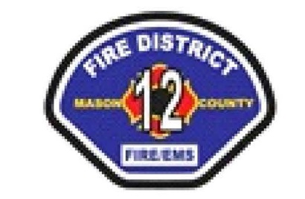

MCFD#12 SPECIAL COMMISSIONER MEETING

Saturday May 9, 2026 9:00am

LOCATION: STATION 1 2950 W Matlock Brady Rd Elma WA 98541

AGENDA

- Call to order. 9:00 pm
2 Flag Salute
3. Roll Call & Guest Introductions
4. Strategic Planning
5. Adjournment
The next Regular Commissioner meeting will be Wednesday May 20, at 6:00pm
at Station 1.

