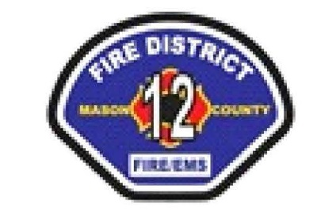

**MCFD#12 PUBLIC LEVY LIFT HEARING**

**Saturday April 19, 2025 at 11:00 am**

LOCATION: STATION 1 2950 W Matlock Brady Rd Elma WA 98541

**AGENDA**

A special meeting of the Board of Commissioners of Mason County Fire District #12 will be held at the aforementioned location and will be held in person. The purpose of this meeting is to review and discuss the districts’ 2025 Levy Lid Lift Proposal in preparation for the Primary election.

No District actions are planned at this meeting. This is an in-person meeting and is open to the public.

1. **Call to order. 11:00 pm**
2. **Flag Salute**

**3. Roll Call**

**4. Levy Discussion**

**5. Adjournment**

The next Regular Commissioner Meeting will be Monday April 28 at 6:00 pm at Station 1.